**Problem Title :**  Modeling a Family Tree in Prolog

**Problem description :**

The Prolog program represents a family tree up to the third generation through facts and rules defining family relationships such as parent, mother, father, siblings, grandparents, aunts/uncles, and cousins. Gender specifications are included to accurately define these relationships. The program can be queried to find specific family relationships within the defined family tree up to the third generation.

**Tools and Languages Used :**

* Prolog
* Notepad++ (for writing and testing Prolog code)
* Graphical tool for drawing family tree (draw.io)

**Diagram :**

Here's the tree structure of my family:

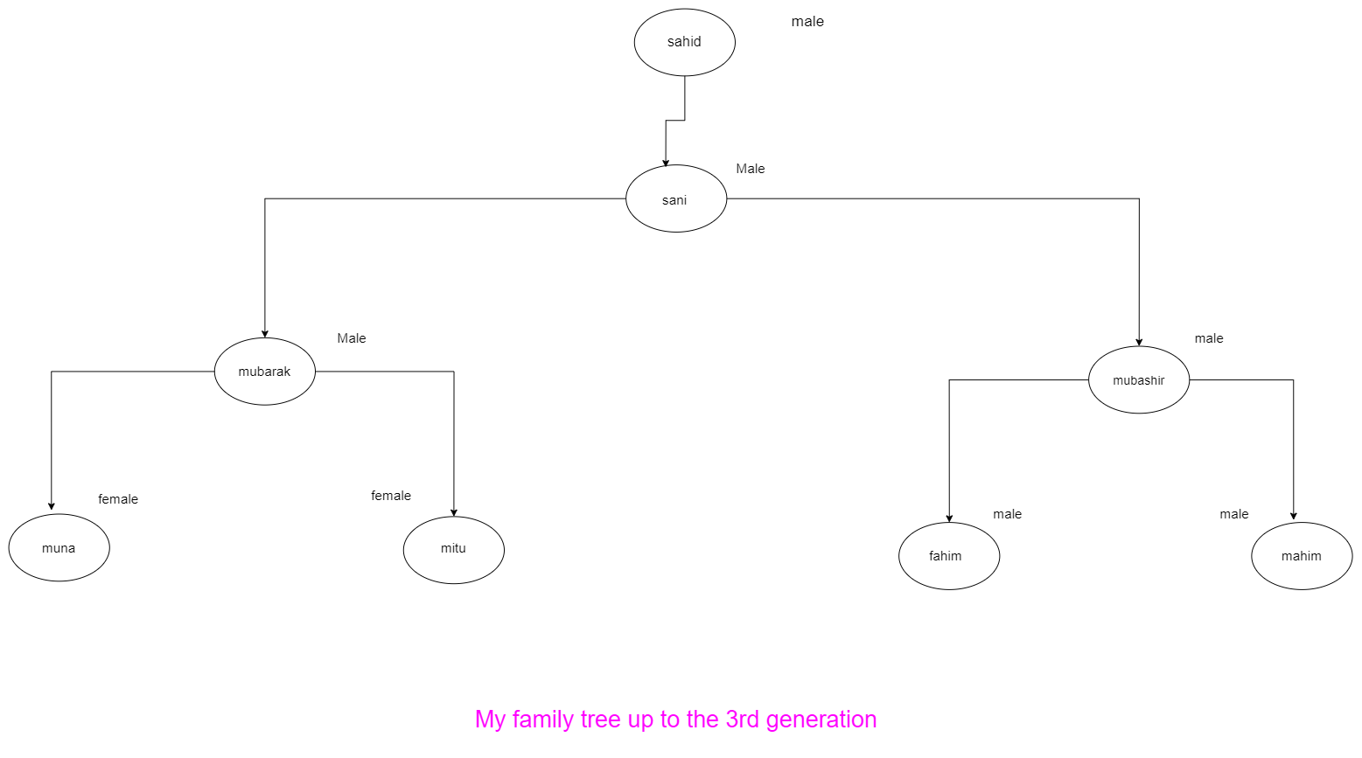

**Prolog Code :**

male(kuddus).

male(sobur).

male(salim).

male(jobbar).

male(bappi).

male(zobayer).

female(mily).

female(mitu).

parents(kuddus,sobur).

parents(kuddus,salim).

parents(sobur,mily).

parents(sobur,mitu).

parents(salim,bappi).

parents(salim,zobayer).

father(X,Y):- parents(X,Y),male(X).

mother(X,Y):- parents(X,Y),female(X).

sibling(X,Y):- parents(Z,X),parents(Z,Y),X \== Y.

grandparent(X,Y) :- parents(X,Z), parents(Z,Y).

grandgrandparent(A,B) :- parents(A,X), grandparent(X,B).

uncle(X,Z):-sibling(X,Y),parents(Y,Z),male(X).

aunty(X,Z):-sibling(X,Y),parents(Y,Z),female(X).

cousin(X,Z):-sibling(W,Y),parents(W,X),parents(Y,Z).

**Sample Input/Output :**

**Query :** All child and father relationship

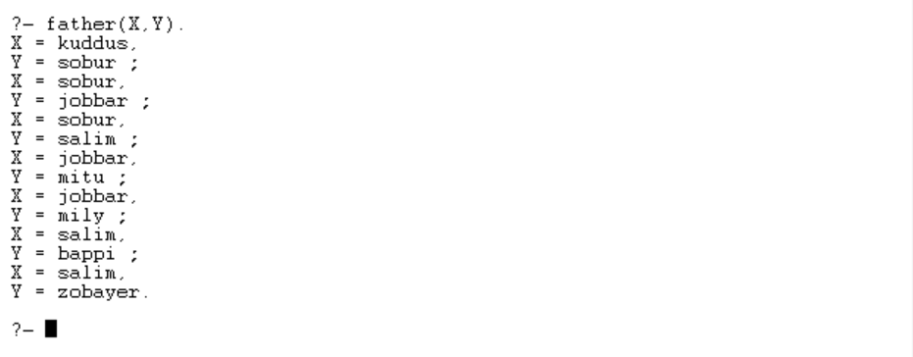**Prolog output :**

**Query :** All sibling relationship

**Prolog output :**

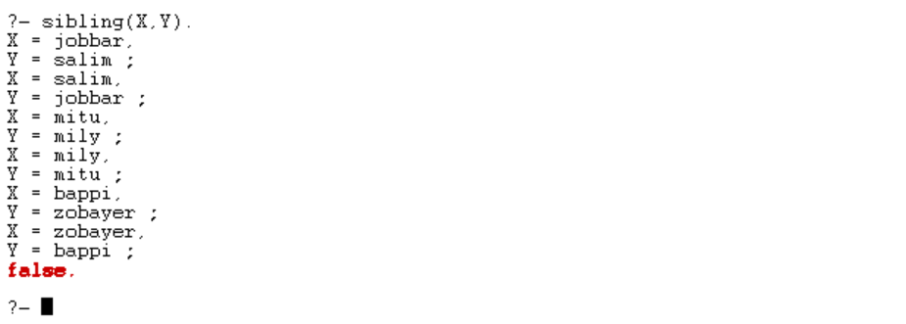

**Query : grand**grandparent list?

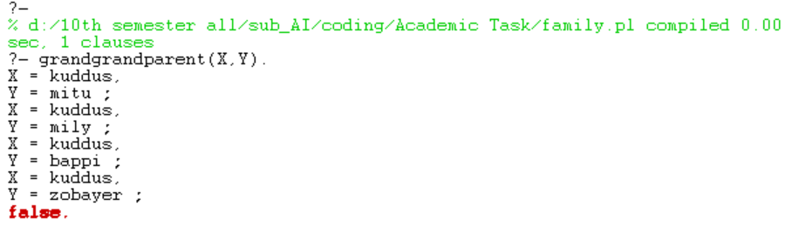**Prolog output :**

**Query :** List of uncle

**Prolog output :**

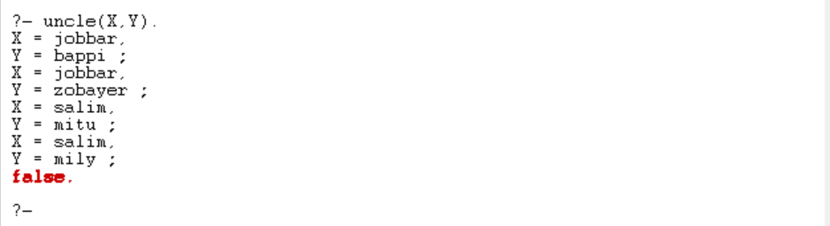

**Query :** who is cousin list?

**Prolog output :**

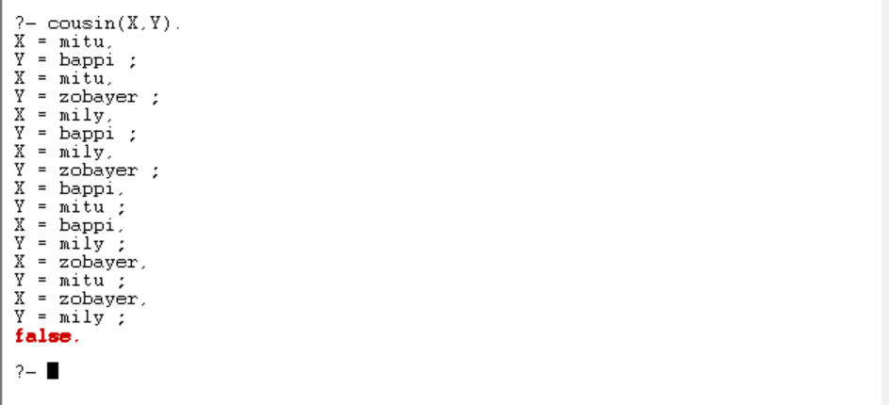

**Query :** All male list?

**Prolog output :**

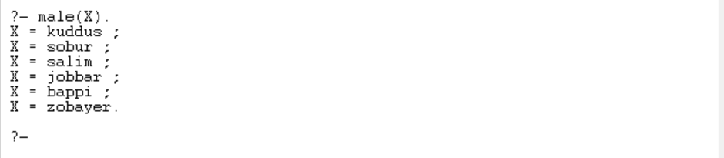

**Query :** all female list?

**Prolog output :**

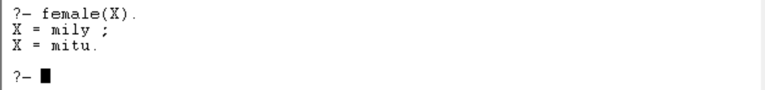

**Conclusion and Challenges :**

This project provided a practical introduction to Prolog and logical programming. Defining family relationships through facts and rules in Prolog was straightforward, but ensuring the correctness of the rules required careful consideration, especially for relationships like cousins and aunts/uncles. The primary challenge was accurately encoding the relationships and ensuring that queries return the expected results. Overall, this exercise has enhanced my understanding of Prolog and logical programming paradigms